Project Design Phase-II
Technology Stack (Architecture & Stack)

Date | 16 Feb 2026
Team ID | LTVIP2026TMIDS84622
Project Name | FlightFinder – Navigating Your Air Travel Options
Maximum Marks | 4 Marks

Technical Architecture:
The Deliverable shall include the architectural diagram as below and the information as per the table1 & table 2
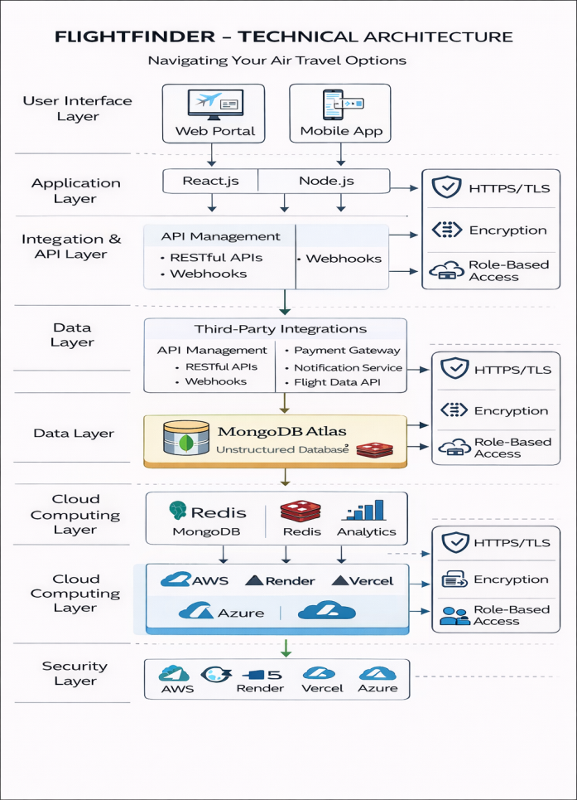

Table-1 : Components & Technologies:
S.No | Component | Description | Technology
 | User Interface | Web interface where users search, compare, and book flights | HTML, CSS, JavaScript, React Js
 | Application Logic-1 | Flight search and filtering logic | Node.js / Express.js
 | Application Logic-2 | Booking management and passenger processing logic | Node.js Backend Services
 | Application Logic-3 | Payment processing and confirmation handling | Payment Gateway Integration (Razorpay / Stripe API)
 | Database | Stores user data, flight details, booking history | MongoDB
 | Cloud Database | Cloud-hosted database for scalability | MongoDB Atlas
 | File Storage | Stores tickets, confirmation PDFs | Cloud Storage / Local File System
 | External API-1 | Fetch real-time flight data (if simulated or integrated) | Flight Data API (Amadeus API / Mock API)
 | External API-2 | Payment Gateway API for secure transactions | Razorpay / Stripe API
 | Machine Learning Model | (Optional future enhancement) Flight recommendation system | Python ML Model (Optional Future Scope)
 | Infrastructure (Server / Cloud) | Deployment of frontend and backend services | Local Server / Cloud (Render / AWS / Vercel)

Table-2: Application Characteristics:
S.No | Characteristics | Description | Technology
 | Open-Source Frameworks | Frameworks used for frontend & backend development | React.js, Node.js, Express.js
 | Security Implementations | Secure login, encrypted passwords, secure payments | JWT Authentication, Bcrypt, HTTPS, Payment Gateway Encryption
 | Scalable Architecture | 3-Tier Architecture (Frontend, Backend, Database) | MERN Stack
 | Availability | 24/7 availability through cloud deployment | Cloud Hosting (Render / AWS / Vercel)
 | Performance | Fast response for flight search and booking | REST APIs, Optimized Queries, MongoDB Indexing

